**Project name : mamaearth**

**Project date : 01/02/2023**

**Tester name : Shreyash Dahikar**

**DEFECTS WITH SCREENSHOTS**

1.

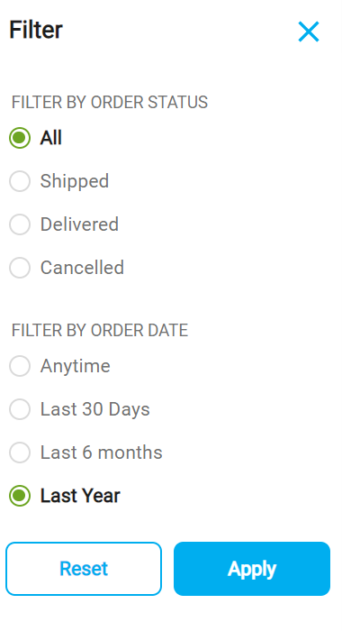

1. This filter show resent order but I Check last year Order Purchase but this filter show this year order.

2.

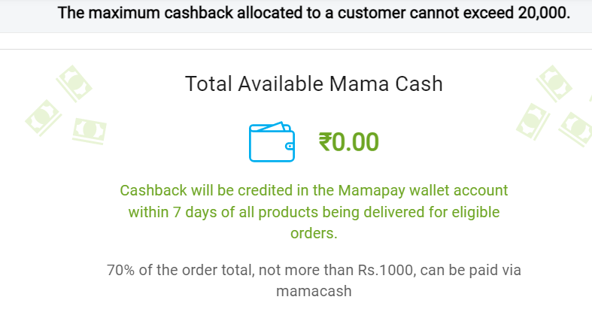

1. Place the order to add this mama cash on payment time then I cancel this order this mama cash point not come mama cash wallet.

3.

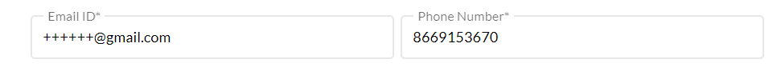

1. This email id was invalid but he accept wrong email id.

4.

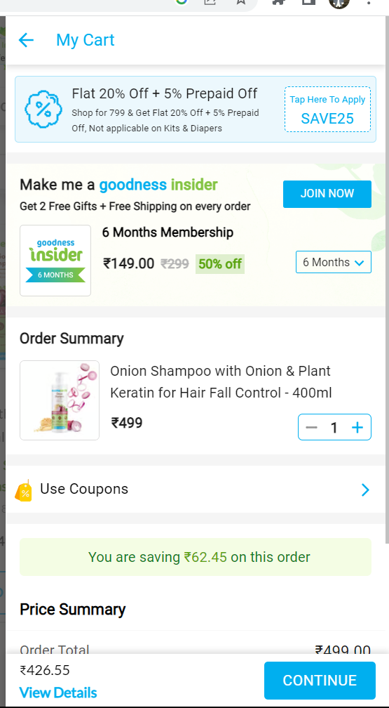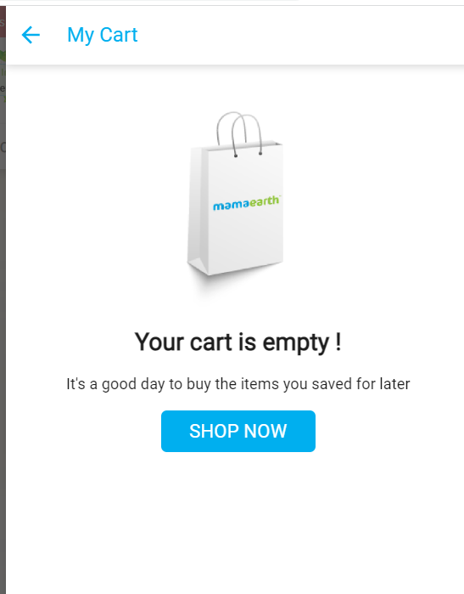

1. I place the order then I cancel my order my product was not show me in my cart option.

5.

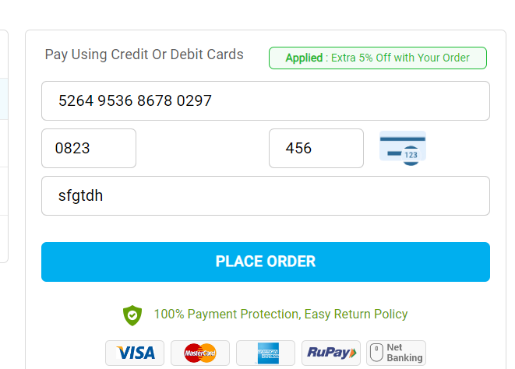

1. This CVV was wrong but he accept.
2. This card holder name was wrong but accept.

6.

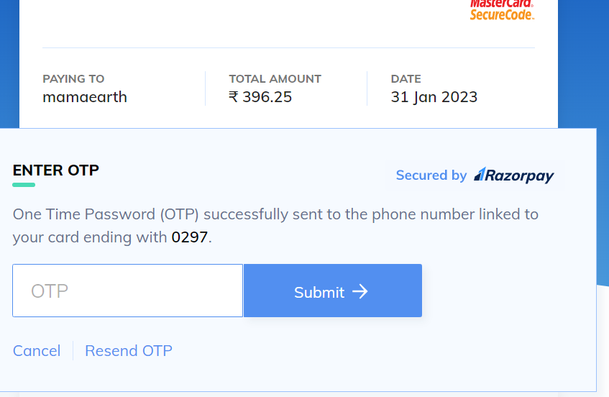

1. Card details was wrong but he send OPT Number.

**TEST CASE**

|  |  |  |  |  |  |  |  |
| --- | --- | --- | --- | --- | --- | --- | --- |
| Req Id | Test Case Id | Pre-Condition | Test case Description | Steps | Input | Expected O/P | Results |
| R1 | TC01 | Check the filter roll | Enter the filter roll. | 1.Click on filter roll button.  2.Enter filter roll.  3.Press Enter button. | Last year | Don’t show last year order | Fail |
|  | TC02 | Check Mama cash | Enter the Mama cash. | 1.Click on Mama cash button.  2.Enter the mama cash.  3.Press Enter button. | Mama cash wallet | Not available this cash point in wallet | Fail |
|  | TC03 | Check invalid Gmail id | Enter your invalid Gmail id | 1 Click on Gmail id page button.  2 Enter your Gmail id.  3 Press Enter button | ++++++@gmail.com | Accept invalid Gmail id | Fail |
|  | TC04 | Check invalid card detail | Enter your invalid card details | 1 Click on card detail page.  2 Enter your Card details.  3 Press Enter button. | 456 | Accept this invalid cvv number | Fail |
|  | TC05 | Check invalid Card holder name | Enter your invalid Card holder Name | 1 Click on holder name page.  2 Enter your holder name page.  3 Press Enter button. | sfgtdh | Accept this invalid card holder name | Fail |